🌐 Remote (Distributed) Testing Using Apache JMeter

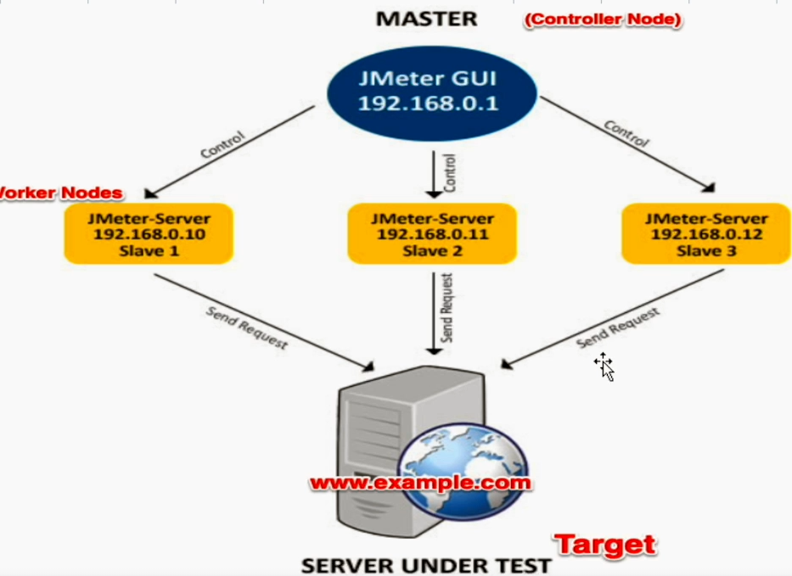

**✅ A. Why Remote (Distributed) Testing is Required?**

Remote (or Distributed) testing in JMeter is used to:

* 🌍 **Simulate load from multiple geographic locations**.
* 📈 **Obtain more realistic and representative performance data**.
* 🧠 **Offload load generation from a single JMeter client**, which may not handle high user volumes.
* 🖥️ **Overcome infrastructure limitations** by leveraging multiple machines.

**🏗️ B. Architecture of JMeter Distributed Testing**

JMeter follows a **Master-Slave model**:

* The **Master** machine:
  + Initiates the test.
  + Sends test plans to Slave machines.
  + Collects results from Slaves.
* The **Slave** machines:
  + Execute the test plan received from the Master.
  + Send results back to the Master.

**⚙️ C. Pre-Requisites**

To set up Remote Testing:

1. ✅ All machines (Master + Slaves) must have:
   * **Java installed** (same version recommended).
   * **JMeter installed** (same version required).
2. ✅ All machines must:
   * Be **connected over a network**.
   * Ideally be in the **same subnet** for ease of communication.

**🛠️ D. Required Configuration Steps**

**On Master Machine:**

1. Navigate to:  
   jmeter/bin/
2. Open jmeter.properties.
3. Locate and edit the following line:

ini

remote_hosts=IP1,IP2

Replace with the IP addresses of all Slave machines.

1. Save and close the file.
2. **Restart JMeter GUI**.
3. From GUI:  
   Run > Remote Start > Select Remote Host(s).

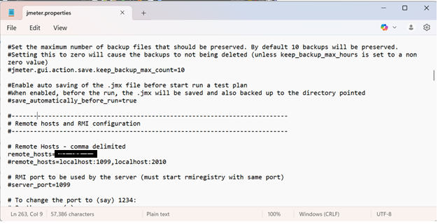

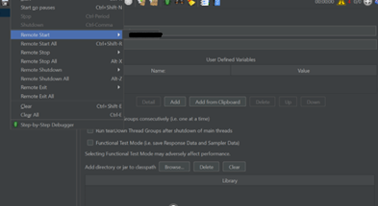

**On Slave Machine(s):**

1. Navigate to:  
   jmeter/bin/
2. Run:
   * Windows: create-rmi-keystore.bat
   * Mac/Linux: sh create-rmi-keystore.sh
3. A file named rmi_keystore.jks is generated.
   * Copy this file into the bin folder of **all remote (slave) hosts**.
4. Start JMeter server:
   * Windows: Double-click jmeter-server.bat
   * Mac/Linux: Run ./jmeter-server from terminal.

**🛠️ Troubleshooting - Loopback Issue (if Master = Slave)**

1. Open:  
   jmeter/bin/system.properties  
   Add this line at the end:

ini

CopyEdit

java.rmi.server.hostname=127.0.0.1

1. Open:  
   jmeter/bin/jmeter.properties  
   Add or update:

ini

CopyEdit

remote_hosts=127.0.0.1

server_port=1099

**🖥️ E. Execution via Command Line**

**On Mac/Linux:**

bash

CopyEdit

sh jmeter.sh -n -t "path/to/test.jmx" -l "path/to/results.csv" -R "IP1,IP2"

**On Windows:**

bash

CopyEdit

jmeter -n -t "path\to\test.jmx" -l "path\to\results.csv" -R "IP1,IP2"

